Supplementary material for “Source characteristics of the 2017 Mw 6.4 Moijabana, Botswana earthquake, a rare lower-crustal event within an ancient zone of weakness”

Kathryn Materna1, Shengji Wei2,3, Xin Wang2, Luo Heng4, Teng Wang2, Weiwen Chen2, Rino Salman2, Roland Bürgmann1

1. Berkeley Seismology Lab, Berkeley CA, USA
2. Earth Observatory of Singapore, Nanyang Technological University, Singapore
3. Asian School of the Environment, Nanyang Technological University, Singapore
4. Wuhan University, Wuhan, China

Macintosh HD:Users:kmaterna:Documents:B_Research:Botswana:joint_inversion:Feb_2018:figS1_stationmap.pdf

**Figure S1**: Map of seismic stations used in the teleseismic inversion.

Macintosh HD:Users:kmaterna:Documents:B_Research:Botswana:joint_inversion:Feb_2018:figSX_model_joint_str332.pdf

**Figure S2**: Model results for the best-fitting inversion on the 332 striking fault plane; see Figure 6 for description of individual panels. The RMS misfit of the InSAR LOS data is 6.2mm.

Macintosh HD:Users:kmaterna:Documents:B_Research:Botswana:joint_inversion:Feb_2018:figS3_waveform_joint_str332.pdf

**Figure S3**: Teleseismic waveform fits for the best-fitting model with a strike of 332 degrees (not preferred in our study). The depth phases of the P-wave arrivals and the SH waves are fit more poorly in this model compared to the model with a strike of 126 (Figure 7). The average waveform cross-correlation coefficient between data and synthetics is 81.1%.

Macintosh HD:Users:kmaterna:Documents:B_Research:Botswana:joint_inversion:Feb_2018:figs4_model_teleonly_str126.pdf

**Figure S4**: Model results from only teleseismic data for the plane with a strike of 126 degrees (similar to Figure 6).

Macintosh HD:Users:kmaterna:Documents:B_Research:Botswana:joint_inversion:Feb_2018:figS5_waveform_teleonly_str126.pdf

**Figure S5**: Waveform fits for the teleseismic-only inversion of data using a fault plane with 126-degree strike (similar to Figure 7).



**Figure S6**. Point source inversion with complex source time function. The black line is the teleseismic P-wave data and the blue line shows the synthetics. Both are in displacement and filtered to the same frequency band as we used in the finite fault inversion. The inverted source time function is shown on the upper left. The station names are displayed to the left of waveform pairs with azimuth indicated below the station name. Features that the model cannot fit, such as the peaks at ~10s, suggest that a finite source dimension is required to explain the data.

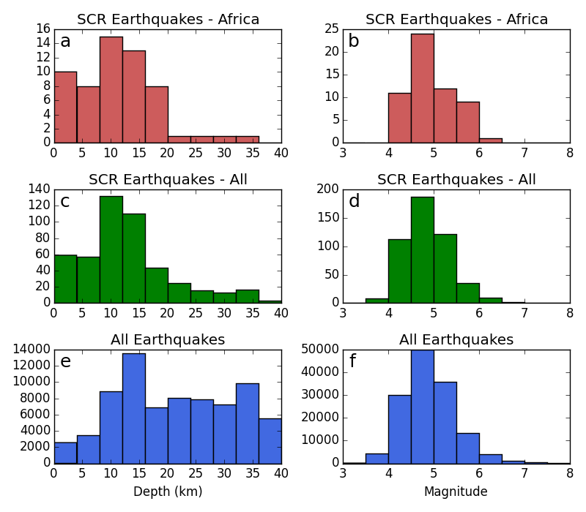

**Figure S7**: Histogram of earthquake depths and earthquake magnitudes in the EHB catalog (Engdahl et al., 1998) up to 40km depth. The stable continental regions (SCRs) shown in the middle panels are the continental shields of Africa, India, Australia, Europe, South America, and North America, representing six of the largest stable continental interiors defined in Johnston (1989). These regions are shown in map view in Figure S7.

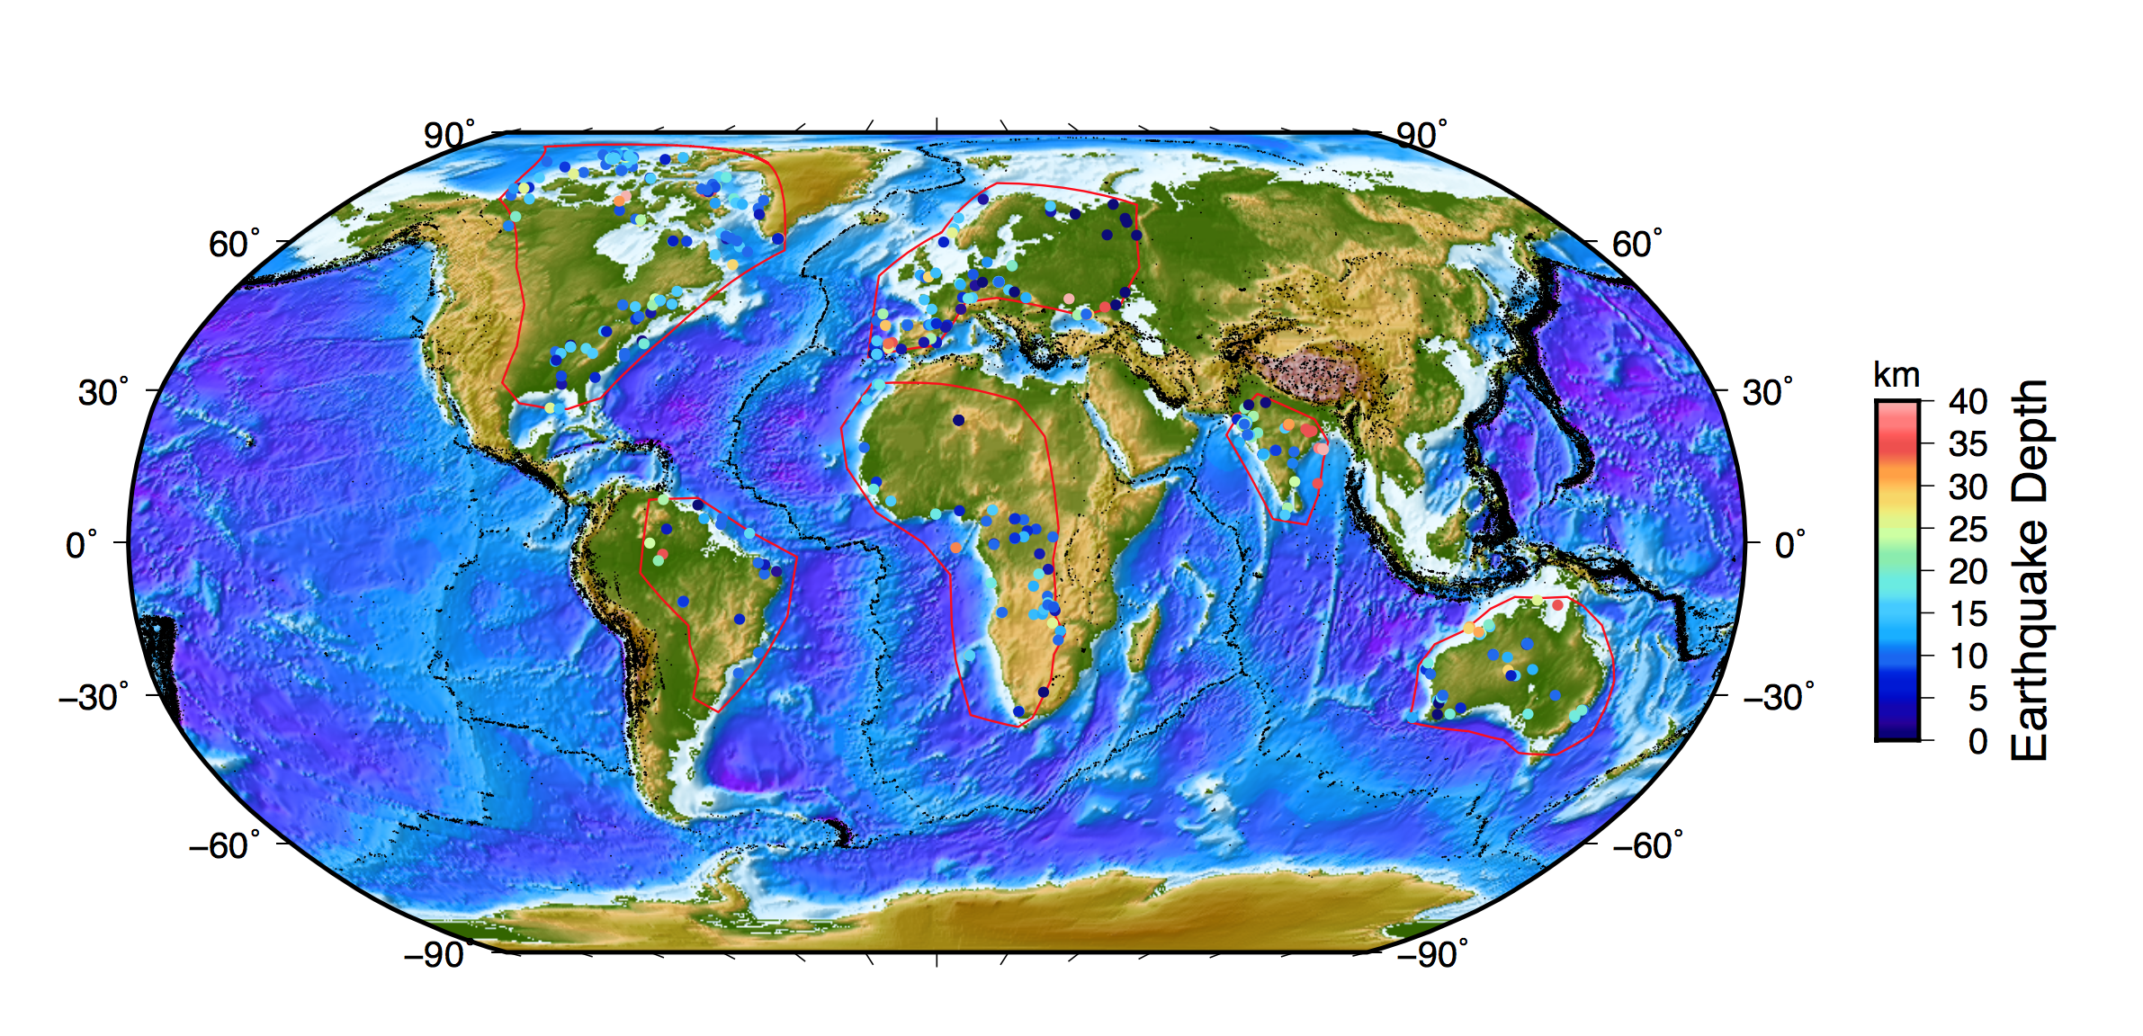

**Figure S8**: Earthquakes in stable continental regions colored by depth. The earthquake catalog is the EHB catalog (Engdahl et al., 1998).

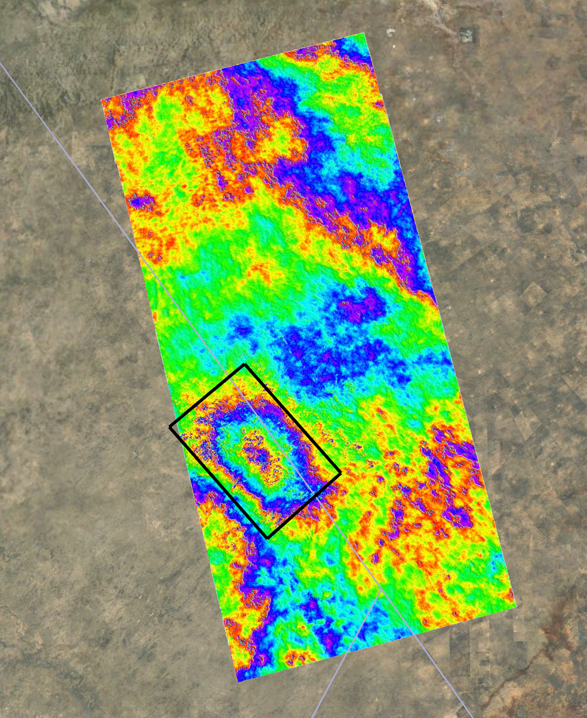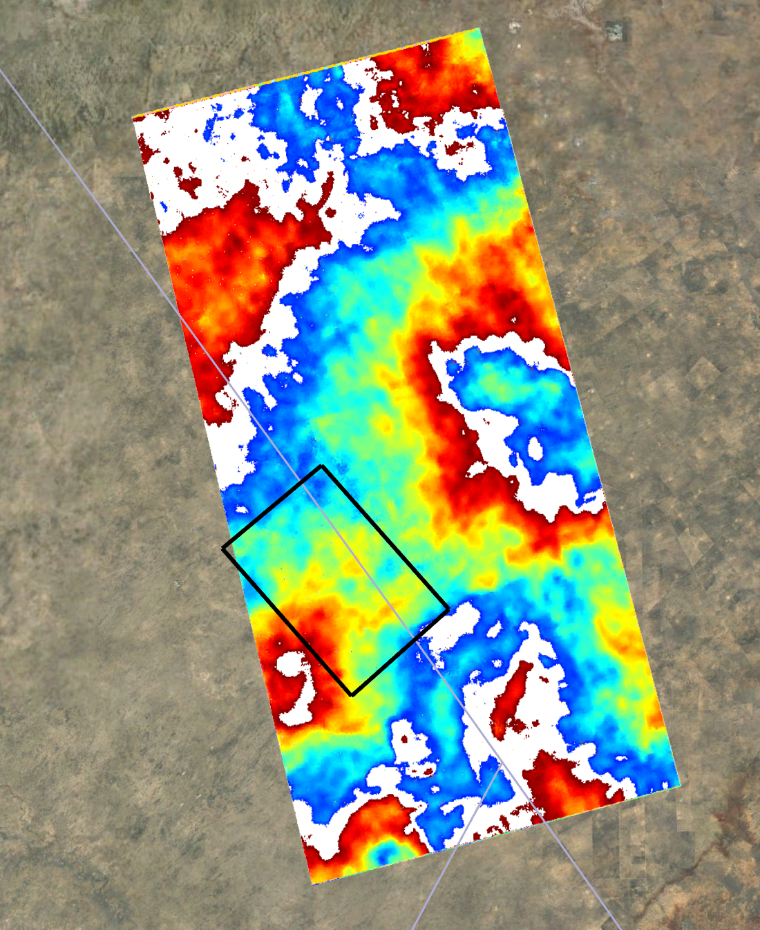

**Figure S9:** Two Sentinel-1 interferograms, one spanning the coseismic period (left) and one spanning the postseismic period from 7 days to 156 days after the earthquake (right). Each fringe represents 2.8cm of line-of-sight displacement. For this event, postseismic displacements appear to be at or below the level of the InSAR noise in the mainshock area (black box).

|  |
| --- |
| Interferograms after event (yyyymmdd) |
| 20170330-20170411 |
| 20170330-20170423 |
| 20170330-20170505 |
| 20170330-20170517 |
| 20170330-20170529 |
| 20170330-20170610 |
| 20170330-20170622 |
| 20170330-20170704 |
| 20170330-20170716 |
| 20170330-20170728 |
| 20170330-20170809 |
| 20170330-20170821 |
| 20170330-20170902 |

|  |
| --- |
| Interferograms before event (yyyymmdd) |
| 20170330-20161224 |
| 20170330-20170105 |
| 20170330-20170117 |
| 20170330-20170210 |
| 20170330-20170222 |
| 20170330-20170306 |
| 20170330-20170318 |

**Table S1**: List of interferograms formed in each interferogram set. All images are co-registered with image 20170330, the last image collected before the earthquake. The two unwrapped interferogram sets, before and after the earthquake respectively, are averaged within each set and then differenced to measure co-seismic deformation.

1. **Focal mechanism inversions for the mainshock and aftershocks**

To obtain the focal mechanism of mainshock, we use the Cut-and-Paste (CAP) method [*Zhu and Helmberger*, 1996] [to invert teleseismic P and SH waves. We collected tele-seismograms from IRIS (](#_ENREF_8)<https://www.iris.edu/hq/>) and inverted for the best double couple solutions by minimizing the misfit between the data and synthetics. The Green’s functions were calculated by using the PREM [*Dziewonski and Anderson*, 1981] [model for the mantle superimposed by 1D regional velocity model from CRUST 1.0](#_ENREF_1) [*Laske et al.*, 2013][. In our inversion, we only used the extended teleseismic P and SH waves, as they are less affected by shallow 3D velocity structures. The source duration is fixed to 8.5 sec based on a scaling equation](#_ENREF_4) [*Ekstrom et al.*, 2012][, since our inversion is less sensitive to the source duration as we used relatively low frequency bands (0.01 – 0.06 Hz). The inversion yields a normal faulting focal mechanism with strike, dip and rake of 308](#_ENREF_3) $°$/118 $°$, 31 $°$/59 $°$ and -82 $°$/-95 $°$, respectively (Figure S9). We also analyzed the uncertainties of the source parameters by the bootstrapping method [*Efron and Tibshirani*, 1991][. Our results indicate that the focal mechanism of mainshock is well constrained and similar to the GCMT solution.](#_ENREF_2)

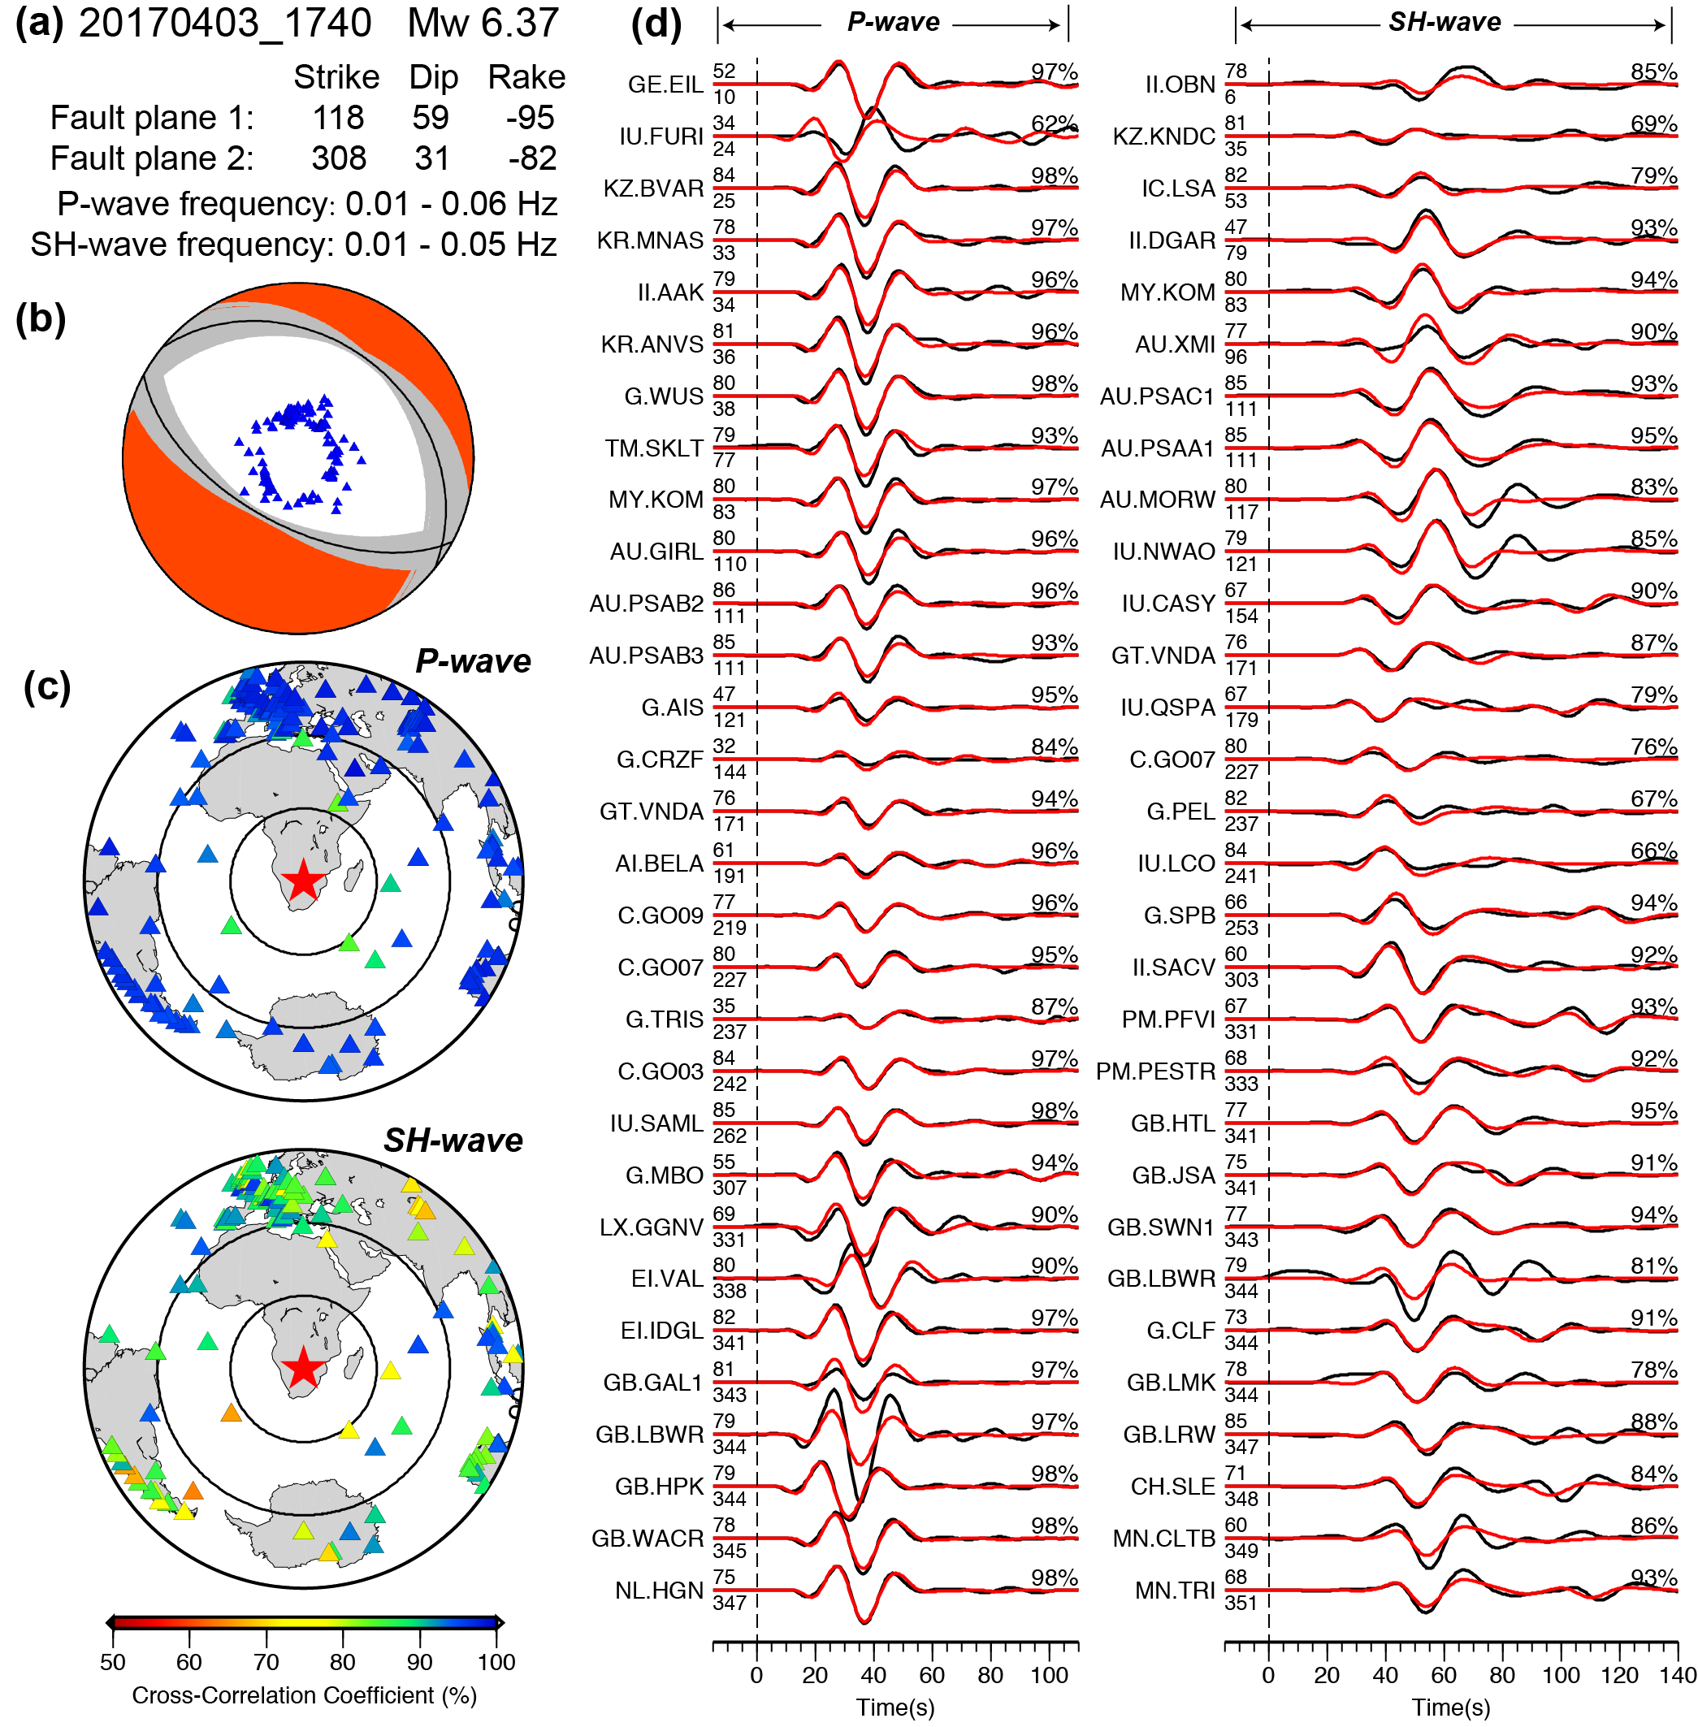

**Figure S9.** Source parameter inversion result for the mainshock. (a) The optimal double couple solution and inversion parameters. (b) The obtained focal mechanism, where the gray lines show the bootstrapping results (within 95% confidence level). (c) The distribution of seismic stations, which are colored by the Cross-Correlation Coefficients (CCC). (d) Representative waveform fits at different azimuths. The black and red lines indicate the data and synthetics, respectively. The station names are indicated on the left of waveform pairs, along with the epicenter distance (upper) and azimuth (lower) in degree. The CCCs are shown at the end of each waveform pair.

1. **Focal mechanism inversion for the aftershocks**

According to the USGS catalog ([https://earthquake.usgs.gov](https://earthquake.usgs.gov/)), the mainshock was followed by 7 aftershocks with magnitude larger than 4.5. We applied the CAP method to invert the focal mechanism of these aftershocks by using regional broadband waveform data. Three of these aftershocks occurred immediately after the mainshock, so their long period signals are contaminated by the surface waves and coda waves from the mainshock. Thus we can only study the later aftershocks that have good long-period signals. Figure S10 shows the distribution of seismic stations used in this study. With the Green’s functions calculated from Crust1.0 model, we inverted the long-period (0.01 – 0.08 Hz) Rayleigh and Love waves to obtain the focal mechanism of three aftershocks (Figure S11 and Table S1), which show similar focal mechanisms to the mainshock.

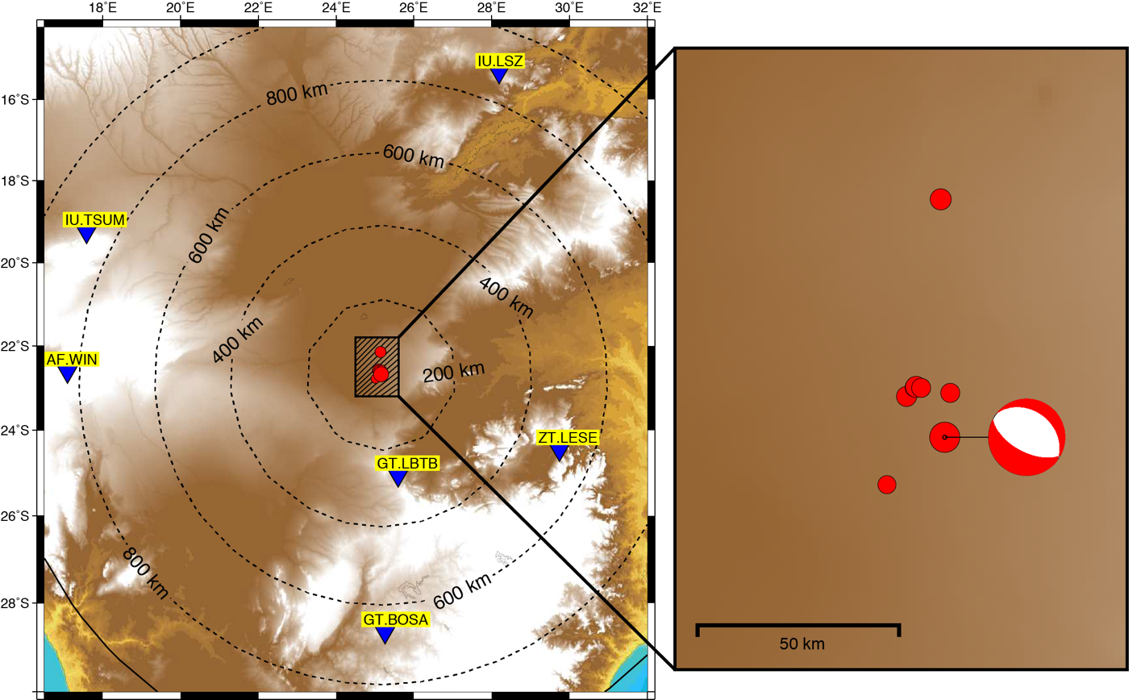

**Figure S10.** The location of earthquakes (USGS catalog) and seismic stations (blue triangles) used in regional CAP inversion.

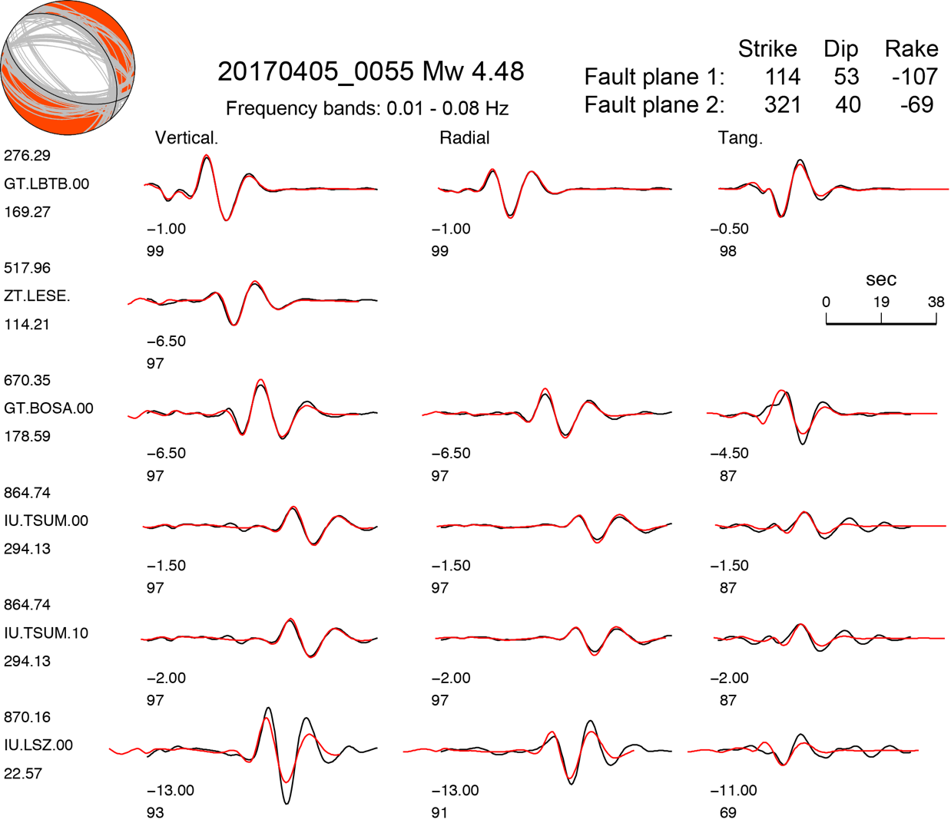

**Figure S11.** Source parameters inversion result for the 2017/04/05 00:55 (UTC) event. The black and red lines indicate the data and synthetics, respectively. The station names are shown on the left, along with the epicenter distance (upper) and azimuth (lower).

1. **Broadband depth-phases modeling**

To refine the depths of the aftershocks we performed broadband depth-phases (pP and sP) modeling using a similar approach as in [*Wang et al.* [2017]](#_ENREF_7) and [*Wang et al.* [2018]](#_ENREF_6).

At teleseismic distances, the ray paths for the direct P phase and the depth-phases are almost identical, except for the region above the source. Thus, the arrival time difference between the direct P phase and depth phases can be used to constrain the focal depth. The resolution of depth increases with frequency, as direct and depth-phases are better separated at high frequency range. We select the frequency range to be as high as we can model, but no higher than reciprocal of the source duration so that the earthquake can still be considered as a point source. The frequency range is selected to be 0.6 – 1.5 Hz for the aftershocks depth phases modeling (magnitude around Mw 4.5). During the modeling, we used the focal mechanism derived in earlier sections and generated a series of synthetics for different focal depths. The optimal depth was then obtained at the highest Cross-Correlation Coefficient (CCC) between the data and the synthetics (Figure S12). Due to the rapidly increasing in number of global seismic stations, we have hundreds of teleseismic waveforms and thus hundreds of estimations of depth for each event. From these dataset, we used data with a CCC above 60% (the threshold varies based on the waveform complexity of each earthquake), and we then obtained the average focal depth and associated uncertainties (Figure S12). The results are also shown in Table S2.

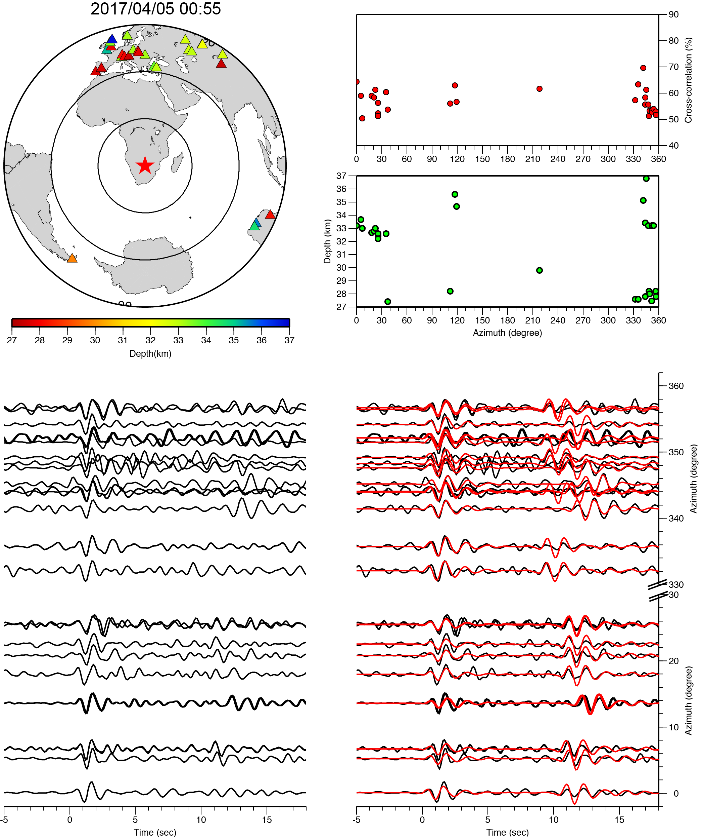

**Figure S12.** High-frequency depth-phase modeling. (a) shows the location of stations and earthquake. The stations are color coded by the best depth. (b) The green and red dots represent the best depth and corresponding cross-correlation coefficient (CCC) at each station, respectively. (c) The representative waveform, with black and red curves represent the data and synthetics, respectively. The waveform fits for the other earthquakes (sorted by origin time) can be found in the following pages.

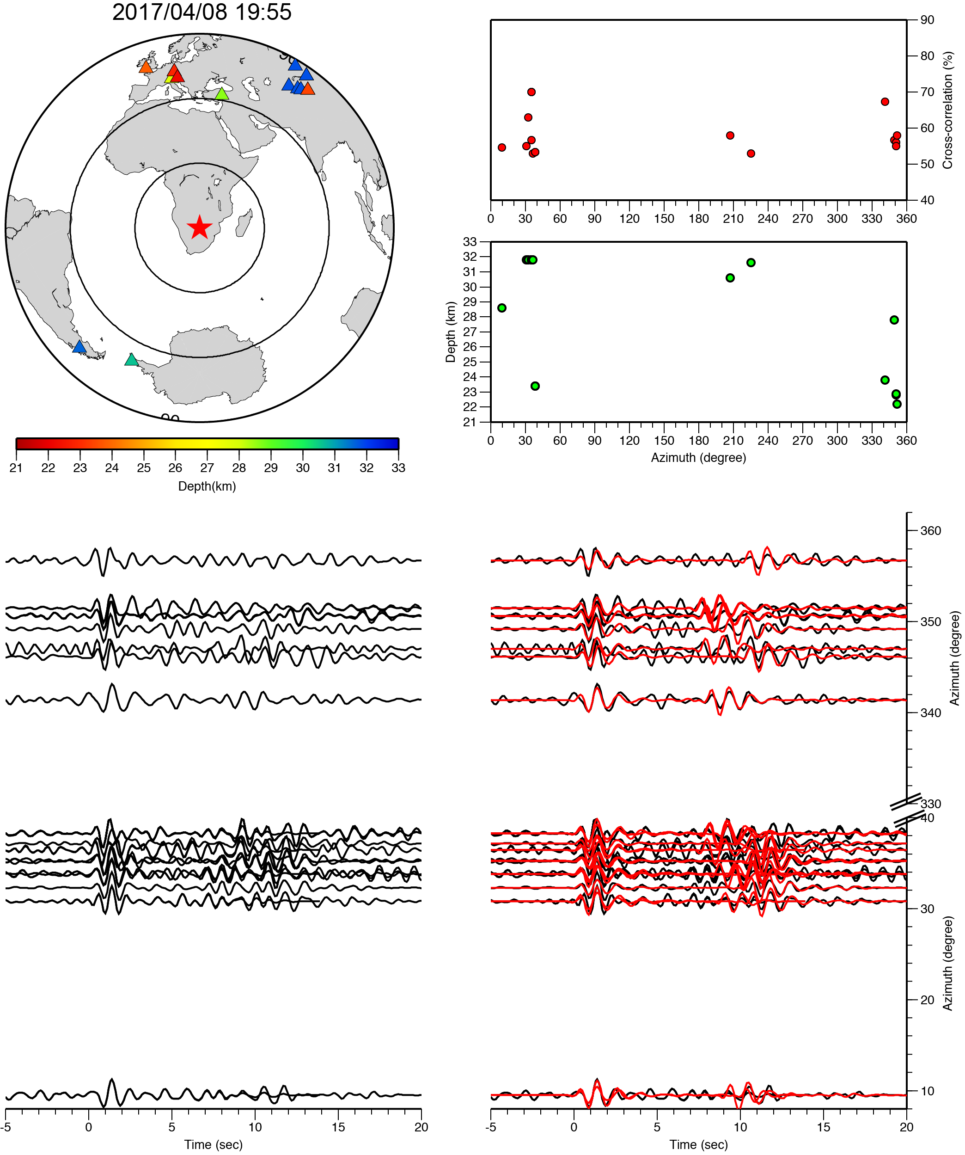

**Figure S12 (continued)**

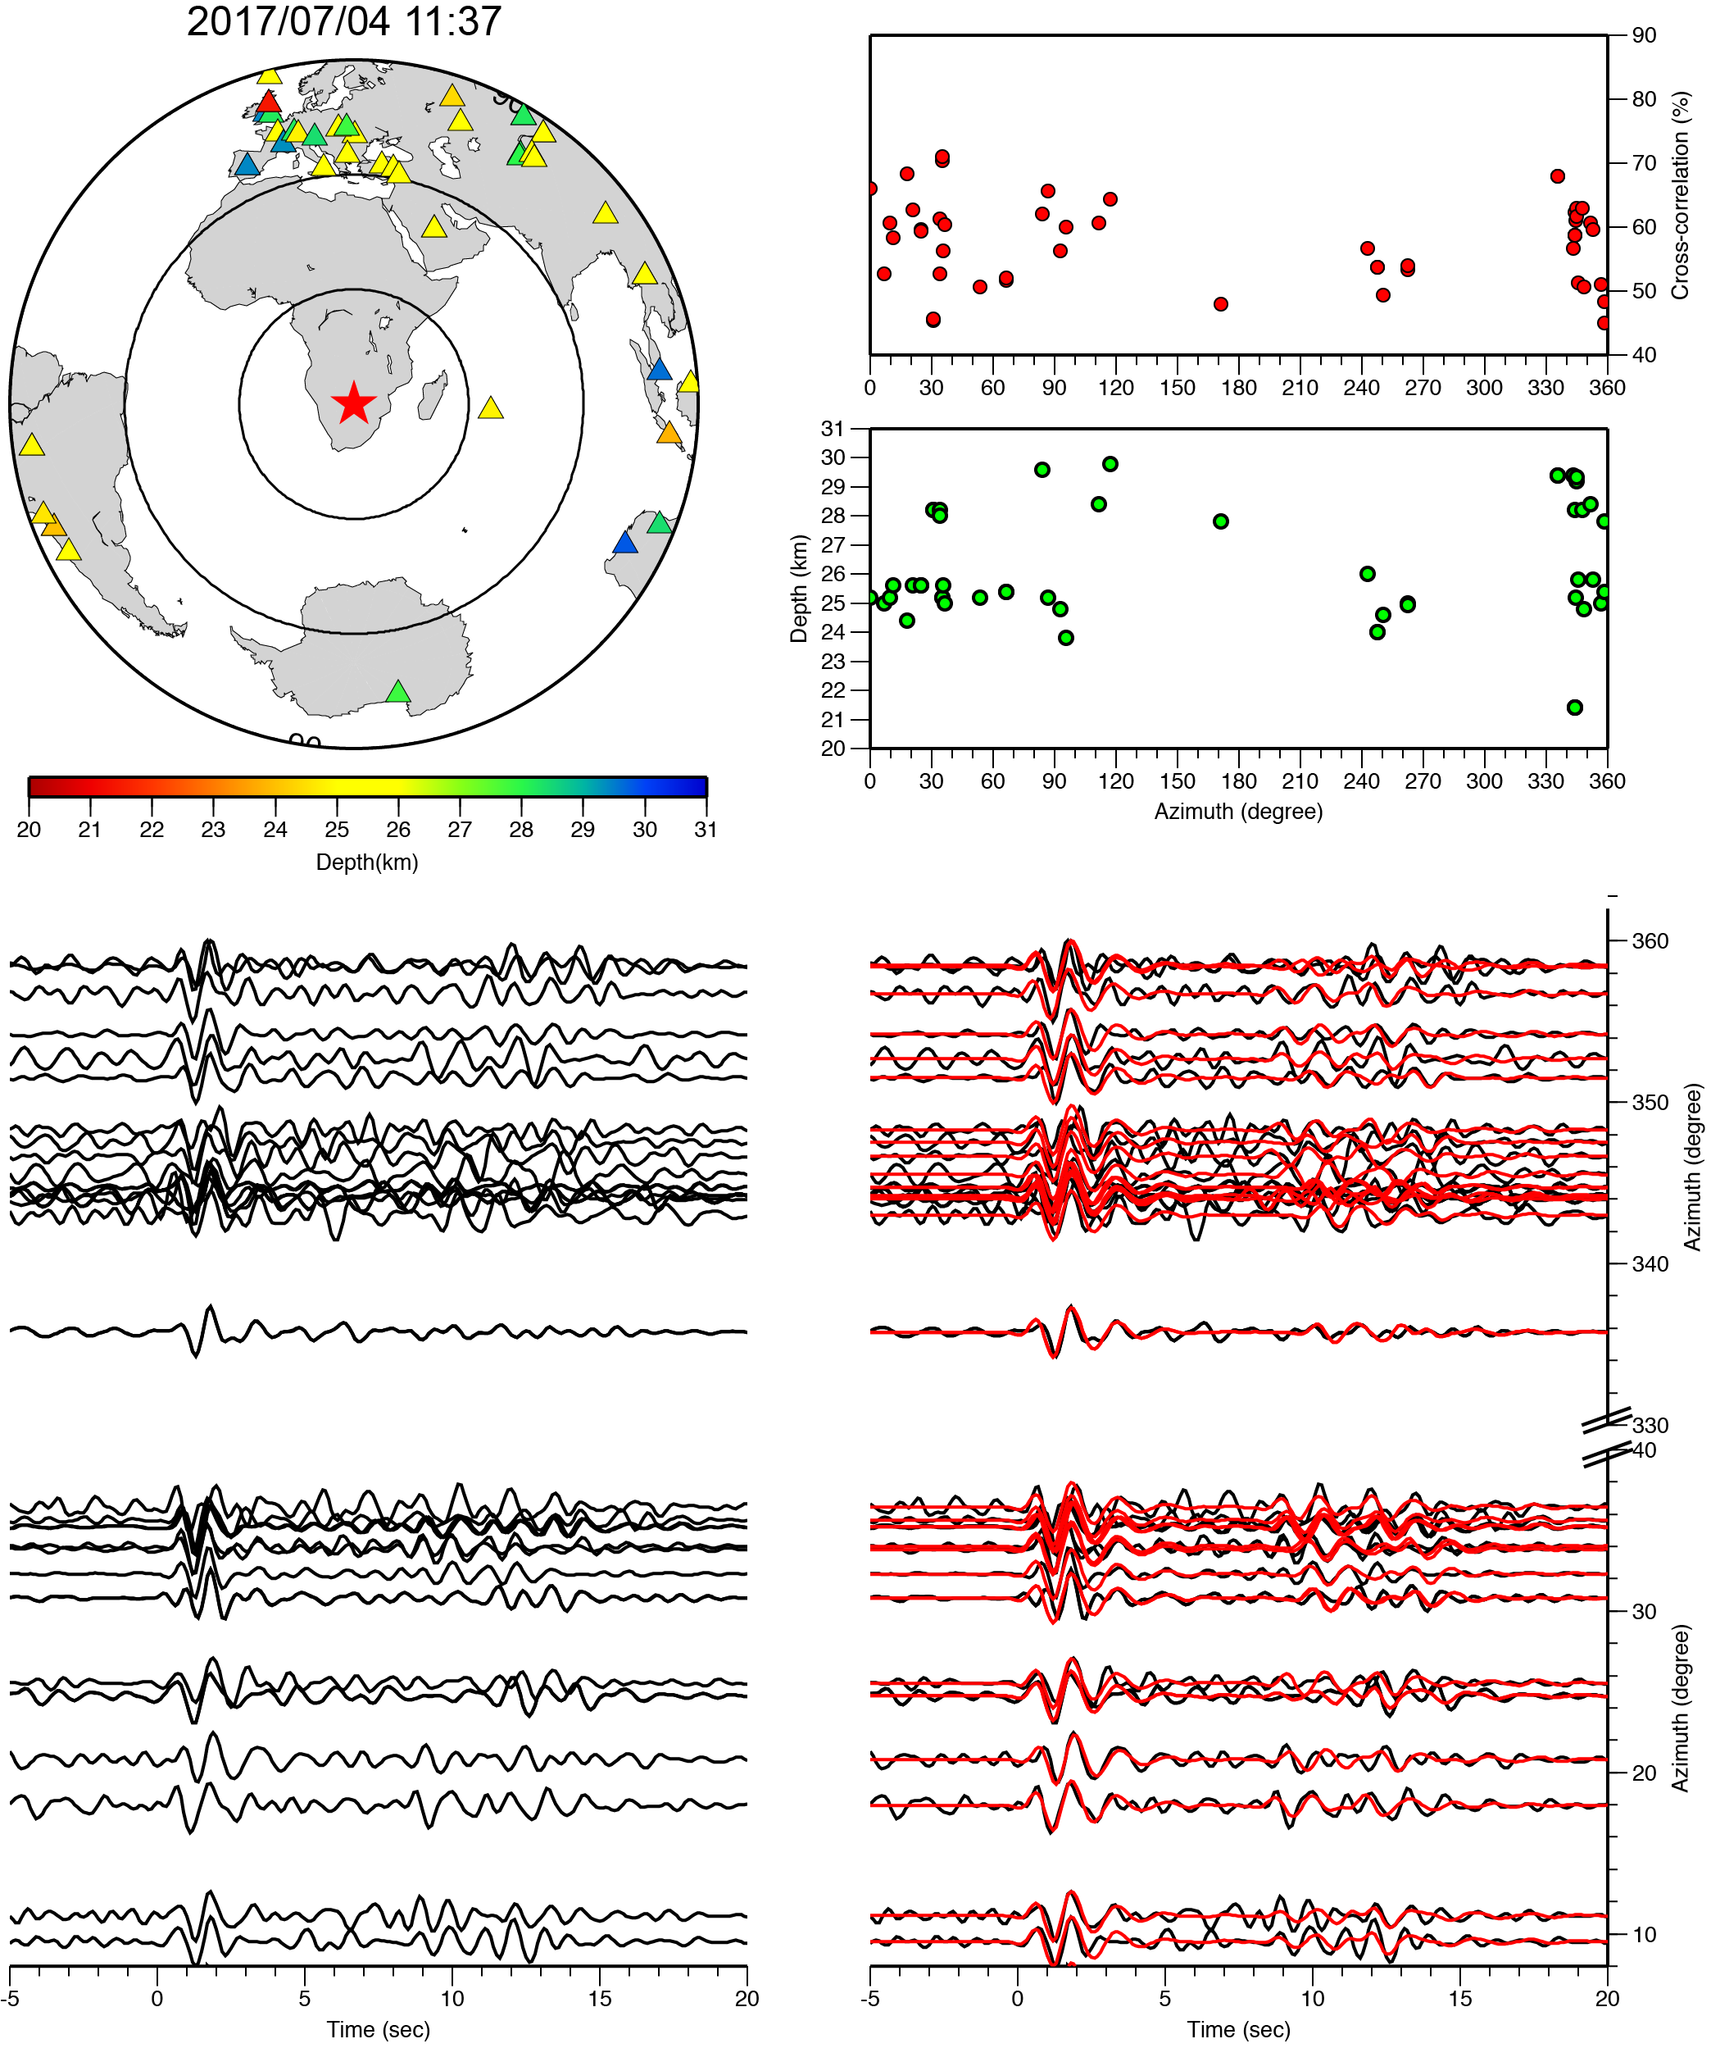

**Figure S12 (continued)**

1. **Refine horizontal location of the aftershocks**

To delineate the geometry of ruptured fault plane with seismicity, the horizontal location of the earthquake is another key parameter we have to better resolve. Here, we relocated the centroid of the aftershocks relative to the mainshock using the surface wave cross-correlation method [*Wang et al.*, 2018][.](#_ENREF_6) The long period surface waves between these earthquakes are highly similar (Figure S12) because of the similar focal mechanism and location. We conducted a grid search to find the best location by minimizing the double differences of the arrival times (Figure S13), following a similar procedure as in [*Waldhauser and Ellsworth*, 2000][. The relocation results are shown in Table S1.](#_ENREF_5)

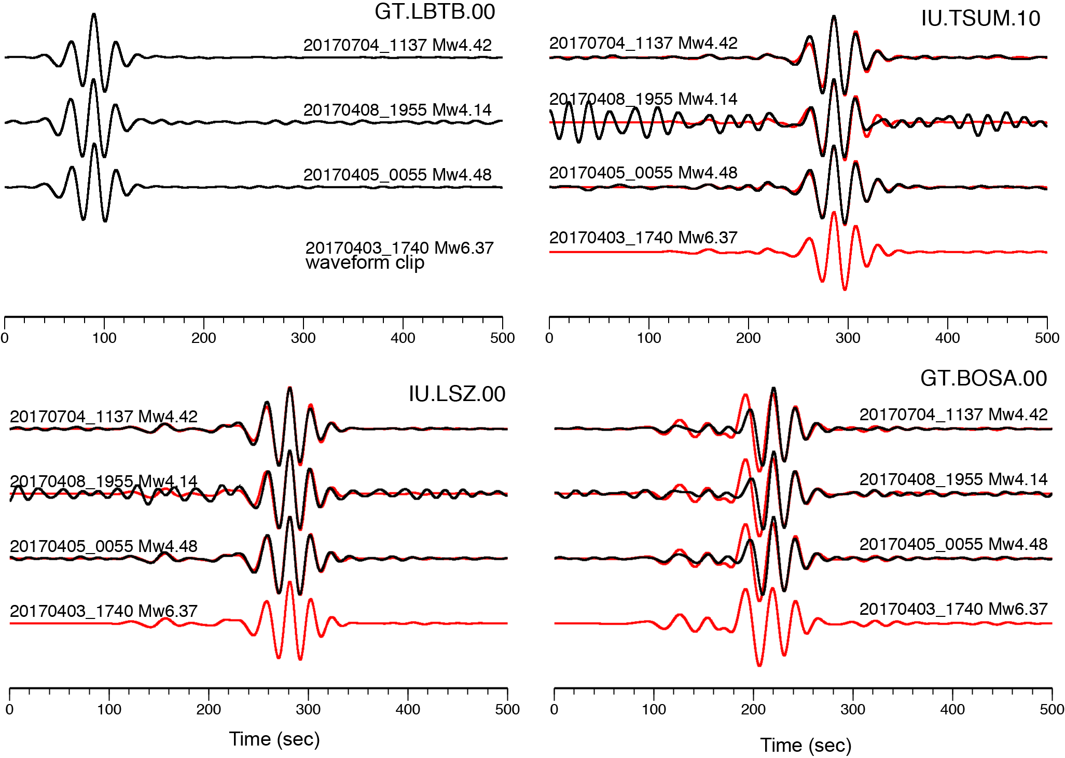

**Figure S13.** Long-period (0.01-0.05 Hz) surface wave comparisons between the mainshock (red) and aftershocks (black) recorded at the regional stations. The waveform amplitudes have been normalized. The station locations can be found in Figure S10.

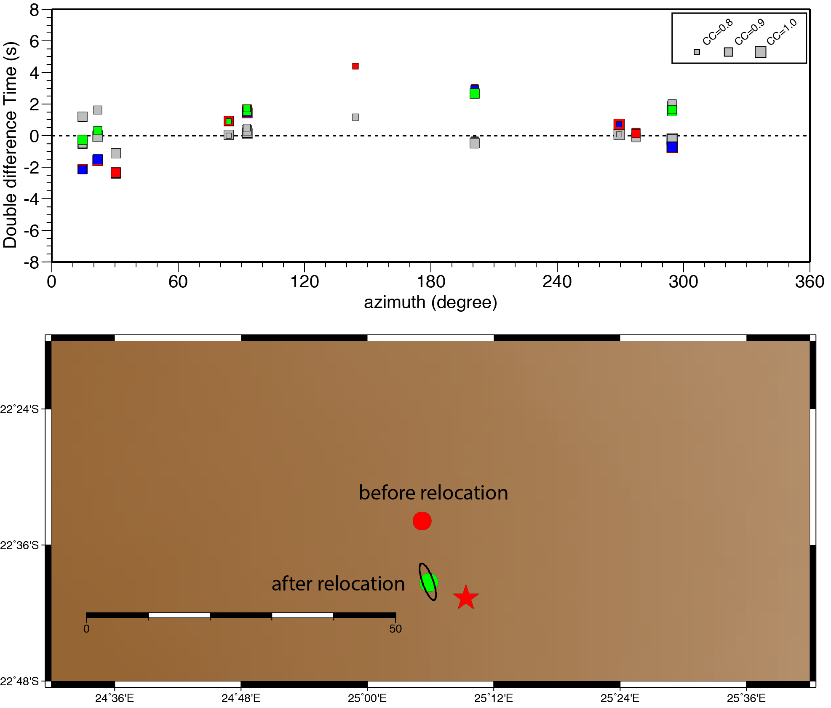

**Figure S14.** Double difference residuals before (colored squares) and after relocation (gray squares). The sizes of the squares are scaled to the Cross-Correlation Coefficients (CCC). We only selected arrival times derived from CCC larger than 80% in our relocation. The relocation result is shown as green circles, with black ellipses showing the error estimated by a bootstrapping method.

**Table S2. Source parameters of earthquakes obtained in this study**

|  |  |  |  |  |  |  |  |
| --- | --- | --- | --- | --- | --- | --- | --- |
| Origin Time | Latitude | Longitude | Depth (km) | Strike | Dip | Rake | Mw |
| 2017/04/03 17: 40 | -22.6780 (USGS) | 25.1560 (USGS) | 29 $\left(hypocenter,USGS\right)$ | 118 | 59 | -95 | 6.37 |
| 2017/04/05 00:55 | -22.6550 | 25.0970 | 31.6 $±2.4$ | 114 | 53 | -107 | 4.48 |
| 2017/04/08 19:55 | -22.6310 | 25.1540 | 28.0 $±3.7$ | 137 | 29 | -90 | 4.18 |
| 2017/07/04 11:37 | -22.6510 | 25.2090 | 26.1 $±1.7$ | 104 | 60 | -99 | 4.42 |

Dziewonski, A. M., and D. L. Anderson (1981), Preliminary Reference Earth Model, *Phys. Earth Planet. Inter.*, *25*(4), 297-356, doi:10.1016/0031-9201(81)90046-7.

Efron, B., and R. Tibshirani (1991), Statistical Data Analysis in the Computer Age, *Science*, *253*(5018), 390-395, doi:10.1126/science.253.5018.390.

Ekstrom, G., M. Nettles, and A. M. Dziewonski (2012), The global CMT project 2004-2010: Centroid-moment tensors for 13,017 earthquakes, *Phys. Earth Planet. Inter.*, *200*, 1-9, doi:10.1016/j.pepi.2012.04.002.

Laske, G., G. Masters, Z. Ma, and M. Pasyanos (2013), Update on CRUST1. 0—A 1‐degree global model of Earth’s crust.

Waldhauser, F., and W. L. Ellsworth (2000), A double-difference earthquake location algorithm: Method and application to the northern Hayward fault, California, *Bull. Seismol. Soc. Amer.*, *90*(6), 1353-1368, doi:10.1785/0120000006.

Wang, X., K. E. Bradley, S. Wei, and W. Wu (2018), Active backstop faults in the Mentawai region of Sumatra, Indonesia, revealed by teleseismic broadband waveform modeling, *Earth Planet. Sci. Lett.*, *483*, 29-38.

Wang, X., S. Wei, and W. Wu (2017), Double-ramp on the Main Himalayan Thrust revealed by broadband waveform modeling of the 2015 Gorkha earthquake sequence, *Earth Planet. Sci. Lett.*, *473*, 83-93.

Zhu, L. P., and D. V. Helmberger (1996), Advancement in source estimation techniques using broadband regional seismograms, *Bull. Seismol. Soc. Amer.*, *86*(5), 1634-1641.